Assignment – 2

Build a python code, Assume u get temperature and humidity values (generated with random function to a variable) and write a condition to continuously detect alarm in case of high temperature.

Program : -

a = int(input("temperature value"))

b = int(input("humidity value"))

if a>50:

if b>90:

print ("alarm is ON")

else:

print("high temperature")

elif a == 50:

print("temperature maximum threshold reached")

else:

print("good temp")

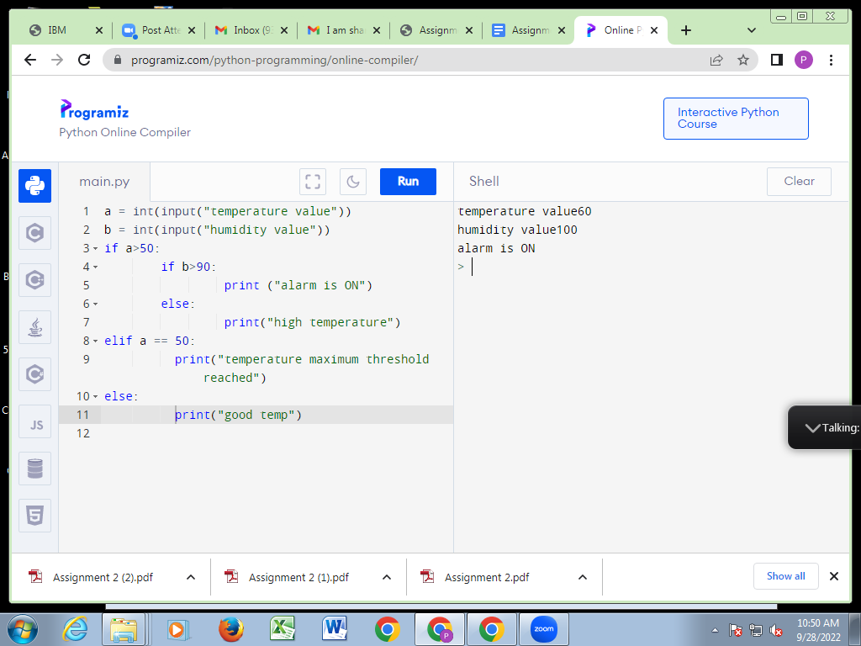

By :- Divi Sushma - 720819106026